SMART HOME AUTOMATION USING VERILOG HDL

Pragnya Chowdary Memparala Department of Electronics and Communication Engineering Vellore institute of technology
Vellore, India
memparala.pragnya2024@vitstudent.ac .in

Brunda Sri Budda Department of Electronics and Communication Engineering
Vellore institute of technology
Vellore, India budda.brundasri2024@vitstudent.ac.in
Debashish Dash* School of Electronics Engineering (SENSE) Vellore Institute of Technology Vellore, India debashish.dash@vit.ac.in

K.Aishwaryanivashini
Department of Electronics and Communication Engineering
Vellore institute of technology
Vellore, India
Aishwaryanivashini. 2024@vitstudent.ac.in

Abstract - Smart home automation represents a rapidly advancing field that integrates digital logic, sensors, and programmable hardware to control and monitor household appliances efficiently. This paper presents the design and simulation of a Smart Home Automation System using Verilog HDL, focusing on hardware-level automation through Finite State Machine (FSM) implementation. The system is modeled and verified using Xilinx Vivado Design Suite, simulating control of devices such as lights, fans, and door locks based on logical conditions. Unlike microcontroller-based approaches, the Verilog design achieves deterministic performance, low latency, and high reliability. The proposed HDL-based design demonstrates scalability for FPGA implementation, offering a flexible and cost-effective framework for intelligent home control.
Keywords - Smart Home Automation, Verilog HDL, FPGA, Finite State Machine (FSM), Digital Design, Xilinx Vivado.

I .INTRODUCTION

Smart home automation has emerged as a major advancement in modern digital technology, integrating electronic devices and sensors to automate and control household functions such as lighting, fans, and security systems. The objective of such systems is to enhance comfort, safety, and energy efficiency by enabling intelligent, responsive, and user-friendly control. As the number of interconnected devices continues to grow, efficient design techniques that ensure fast and reliable operation have become essential.
Traditional automation systems primarily rely on microcontrollers and IoT-based architectures, which, although flexible, depend heavily on sequential software execution. This dependence introduces limitations such as slower response time, software errors, and higher power consumption. In contrast, Hardware Description Language (HDL)-based designs, particularly using Verilog HDL, allow the control logic to be implemented directly in hardware. Such designs support parallel processing, resulting in faster, deterministic behavior suitable for real-time applications.
In this project, a Smart Home Automation System using Verilog HDL is designed and simulated using Xilinx Vivado Design Suite. The system operates on a Finite State Machine (FSM) model to control multiple home appliances based on input conditions, ensuring predictable state transitions and efficient power management. The hardware-level approach offers improved reliability and scalability, eliminating the delays inherent in software-controlled systems.
Furthermore, the proposed Verilog-based system offers flexibility and scalability for future expansion. Additional modules can be integrated for advanced functionalities, such as temperature-based fan control, motion-based lighting, or security features like automatic door locks. The architecture also allows easy migration to FPGA hardware implementation, which can be further enhanced by integrating IoT communication modules for remote monitoring and control.
The remainder of this paper is organised as follows: Section II presents related work and identifies the research gap. Section III defines the problem statement. Section IV describes methodology, system design, and FSM implementation. Section V discusses simulation results and performance analysis. Section VI concludes the paper with key outcomes and future enhancements, while Section VII lists the references used in this study.

Literature Review
Smart home automation systems have evolved significantly over the past decade with the integration of IoT, microcontrollers, and wireless communication modules. However, most of these systems are largely software-dependent, leading to limited scalability, slower real-time response, and higher chances of malfunction due to firmware or communication failures. Software-controlled systems also require continuous processing and data exchange, resulting in increased power consumption and latency, which may not be ideal for time-critical automation tasks.
While recent advancements in embedded control and IoT frameworks have made automation more accessible, they still rely on sequential instruction execution, which restricts parallel control of multiple devices. Furthermore, these systems are susceptible to software bugs, communication delays, and compatibility issues between different modules. Such challenges reduce system reliability, especially when operating several appliances simultaneously or in safety-critical environments such as security or fire-alarm systems.
To overcome these limitations, hardware-level automation using Verilog HDL and Finite State Machine (FSM) logic offers an efficient alternative. HDL-based design enables parallel execution, deterministic behaviour, and low-latency control at the logic gate level. Despite these advantages, only a few studies have explored the use of Verilog HDL for comprehensive home automation. Most existing works implement HDL modules only for specific devices, lacking an integrated FSM-based control structure that can manage multiple household functions within a unified design.
Problem Statement:
To design and simulate a Verilog HDL-based Smart Home Automation System using FSM logic that ensures efficient, reliable, and real-time control of multiple home appliances with low latency and minimal power consumption.
Research Gap:
Although numerous smart home systems have been developed using microcontrollers and IoT technologies, most of these rely on software-based control, which limits their real-time responsiveness and reliability. These systems operate sequentially, leading to higher latency and reduced efficiency when managing multiple devices simultaneously. Moreover, they depend on firmware and communication networks, which makes them prone to software errors, network delays, and inconsistent timing behaviour. In contrast, hardware-level automation using Verilog HDL offers deterministic control and true parallel processing, but only limited research has focused on this approach. Very few studies have implemented complete FSM-based smart home architectures that utilise Verilog for efficient, low-power, and scalable device control. This gap highlights the need for a fully hardware-defined automation framework capable of delivering faster, more reliable, and flexible operation compared to traditional software-driven systems.

IV.METHODOLOGY
The design, implementation, simulation, and verification method for the smart home automation system relies on established digital design principles. It emphasizes the practical use of Verilog HDL and ModelSim to achieve strong hardware-level control and real-time automation.
Requirements Identification
We conducted an extensive analysis to identify requirements by reviewing current smart home literature and case studies. This helped us outline important functional and safety features. We specified key system inputs, including door, light, temperature, smoke, gas, rain, water level, and motion sensors, as well as a password-based authentication subsystem. The outputs included door locks, alarms, lighting, climate control, resource management (water pump), exhaust, sprinklers, curtains, an emergency LED, and a temperature display. Our requirements highlighted the need for predictable responses, concurrency, and reduced latency.

System Architecture Design
We organized the system into functional modules, each designed as Finite State Machines (FSMs) for reliability.
Security FSMs managed access control, alarm activation, and emergency signaling. They used password authentication and intrusion detection.
Environmental FSMs controlled the lights based on input from sensors for ambient light and motion, and they managed temperature controls (AC/heat) based on sensor data.
Safety and Resource FSMs monitored hazardous events like smoke and gas. They automated the exhaust and sprinklers, controlled the water pump based on water levels, and adjusted the curtains in response to rain.
We created hierarchical block diagrams and state transition tables to define input-output relationships and timing constraints for each subsystem.
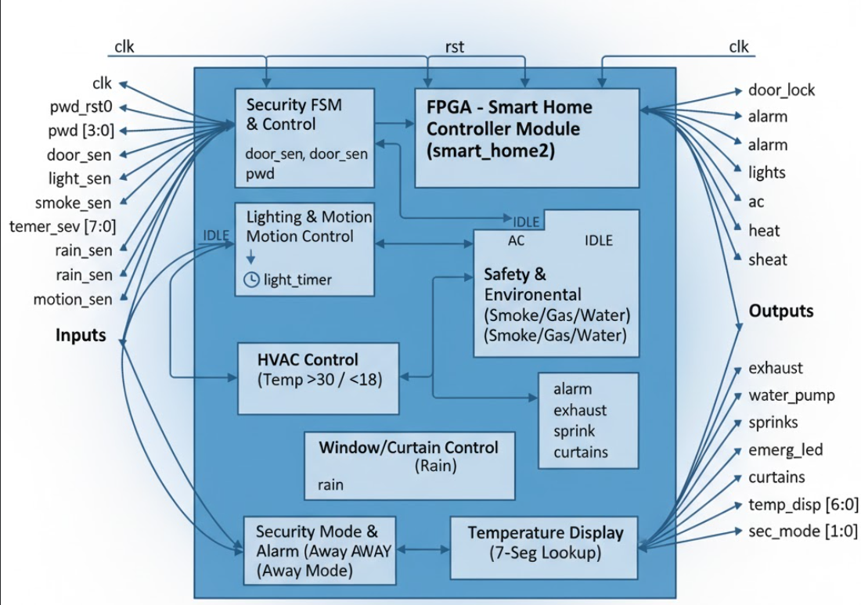
Verilog HDL Implementation
We chose Verilog HDL for its ability to express hardware concurrency, state machines, and synthesizable logic. We encoded each device and control subsystem as a modular FSM, complete with clear transitions, output behaviors, and fail-safe reset routines. Signal naming followed readable conventions, and inline comments provided documentation for state logic and interface connections, making it easier for peers to review.
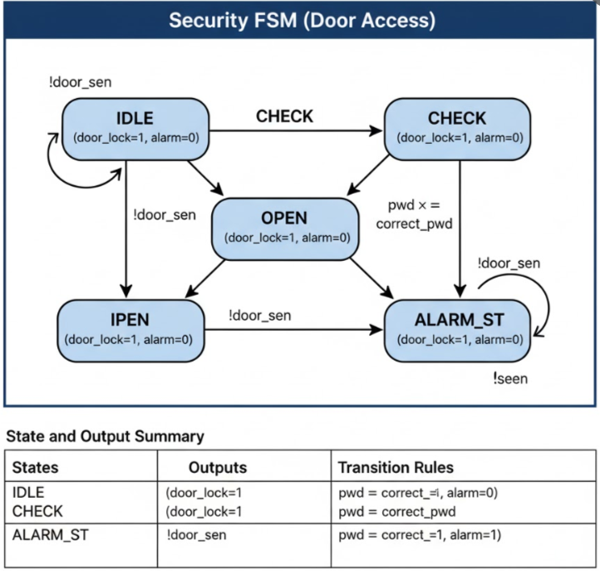

Testbench and Simulation
We developed a comprehensive testbench (smart_home2_tb) to thoroughly stimulate every functional scenario that mirrors real home events.

Initialization and Reset: We set signals like clk, rst, and all sensor inputs and outputs to baseline values. The simulation began with the system in a known, safe state.
Sequential Scenario Simulation: We scheduled password entry (both correct and incorrect), changes in sensors (like darkness onset, motion detection, gas leaks, fire, rain, and shifts in water levels), and mode changes (away/normal) using timed procedures and delays.
Realistic Timing: The testbench incorporated time intervals with # delays to mimic actual hardware response times, allowing us to observe transitions in ModelSim.
Output Monitoring: We tracked simulation outputs in real time using $monitor and $display statements for console logs. The $dumpfile and $dumpvars directives helped us capture waveform data for detailed graphical review, as shown in the ModelSim output screenshot.
Waveform Analysis: The ModelSim output visualizes the signal transitions of each module over time. This confirms the correctness of the FSMs, clock synchronization, device activation sequences, and sensor interactions.
Signal Observation: We inspected output traces for the door lock, heater, lights, water pump, and other modules to ensure they activated correctly based on relevant inputs, supporting our deterministic design goals.
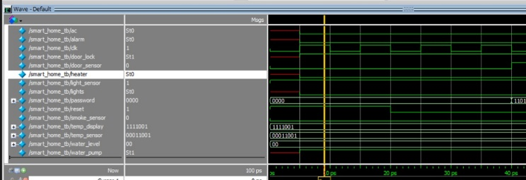
Iterative Debugging and Verification
We conducted simulations iteratively, validating each scenario’s outputs against truth tables and design expectations. Any unexpected behavior prompted a review of the code and adjustments to the testbench, with repeated runs until all scenarios produced consistent results. We explicitly tested edge cases such as rapid multi-sensor triggers, concurrent hazards, and resets to ensure system stability.
Documentation and Diagrams
We maintained detailed records of FSM logic, input-output maps, block diagrams, and waveforms to support our results and analysis. We included screenshot evidence from ModelSim, like the attached output, to provide visual proof of correct hardware operation.
Limitations and Future Directions
Our methodology acknowledges that timing and functional models are based on simulation. It suggests future work on hardware synthesis (FPGA or ASIC), improving sensor interface robustness, and integrating cloud solutions for remote monitoring. The modular structure of our system supports further research, extensions, and adjustments for new devices.

VI. CONCLUSION

Hardware-based design can greatly increase automation systems' responsiveness, efficiency, and dependability, as shown by the creation of a smart home automation system using Verilog HDL and Finite State Machine (FSM) logic. Based on sensor inputs, the system in this project was created to regulate vital home appliances like water pumps, fans, door locks, lights, and alarms. Compared to traditional microcontroller or Internet of Things-based approaches that mainly rely on sequential software execution, the hardware description approach guarantees that control decisions are carried out directly at the logic level, offering faster and more reliable performance.
FSM-based design methodology ensured deterministic responses to a range of input conditions, including motion detection, temperature changes, gas or smoke detection, and security alerts, by clearly defining system behavior through discrete states and transitions. Because each subsystem was created as a separate FSM, the system as a whole was scalable, modular, and simple to change or grow in the future. Without requiring significant architectural changes, this modularity enables the addition of new intelligent features like energy-saving modes, environmental monitoring, and automated curtain control.
Another important result of this project is showing how Verilog HDL can be used for more than just regular digital circuits. It can also be used for smart control systems. HDL-based designs work in parallel, which means that they can control more than one device at a time. This is a big advantage over software-based systems, which process instructions one at a time. This parallelism also helps the design use less power and run faster, which makes it good for FPGA-based and embedded applications.
This work lays a solid groundwork for real-world use with FPGA hardware beyond the simulation phase. In the future, it might be possible to add wireless communication modules like Wi-Fi, Zigbee, or Bluetooth to make IoT-based remote monitoring and control possible. You can also add machine learning algorithms or sensor fusion techniques to the system to make it adaptive, like learning how users behave or automatically optimizing energy use.

VII.REFERENCES

[1] Gayatri, K. M., Shriya, P., Manjusha, K., Ankarao, V., & Gangaprasad, G. (2025). Smart Home Automation using IoT - A Modern Lifestyle Revolution. 2025 6th International Conference on Electronics and Sustainable Communication Systems (ICESC), Electronics and Sustainable Communication Systems (ICESC), 2025 6th International Conference On, 1385–1390. https://doi-org.egateway.vit.ac.in/10.1109/ICESC65114.2025.11212429

[2] Nalini, N., Elrashidi, A., Vaishnavi, T., Rosi, A., Manideep, B., & Karthikeyan, G. (2025). An AIoT-Enabled Smart Home Automation Framework: Intelligent Control, Security, and Predictive Monitoring. 2025 6th International Conference on Electronics and Sustainable Communication Systems (ICESC), Electronics and Sustainable Communication Systems (ICESC), 2025 6th International Conference On, 634–638. https://doi-org.egateway.vit.ac.in/10.1109/ICESC65114.2025.11212291

[3] M, P. S., J, H., & K, J. (2025). A Multi-Protocol IoT-Enabled Touch Control Switch for Energy-Efficient Smart Home Automation. 2025 Second International Conference on Cognitive Robotics and Intelligent Systems (ICC - ROBINS), Cognitive Robotics and Intelligent Systems (ICC - ROBINS), 2025 Second International Conference On, 133–139. https://doi-org.egateway.vit.ac.in/10.1109/ICC-ROBINS64345.2025.11086234
[4] Tanvir, M. A., Ahmed Irfan, F., & Iqbal, R. (2025). SEAD: Sensor Event-Based Anomaly Detection for Smart Home Automation. 2025 IEEE 49th Annual Computers, Software, and Applications Conference (COMPSAC), Computers, Software, and Applications Conference (COMPSAC), 2025 IEEE 49th Annual, COMPSAC, 1492–1497. https://doi-org.egateway.vit.ac.in/10.1109/COMPSAC65507.2025.00187

[5] Hasan, R., Sakib, M. S. A., Ahmed Ashan, F., Islam, M. R., & Das, S. C. (2025). WhatsApp Based Smart Home Automation System. 2025 2nd International Conference on Next-Generation Computing, IoT and Machine Learning (NCIM), Next-Generation Computing, IoT and Machine Learning (NCIM), 2025 2nd International Conference On, 1–6. https://doi-org.egateway.vit.ac.in/10.1109/NCIM65934.2025.11160264

[6] Kumar, P. V., Prathyusha, A., HimaBindu, N., & Manaswini, P. (2025). Intelligent IoT System with AI and ML Integration for Smart Home Automation. 2025 5th International Conference on Trends in Material Science and Inventive Materials (ICTMIM), Trends in Material Science and Inventive Materials (ICTMIM), 2025 5th International Conference On, 1107–1114. https://doi-org.egateway.vit.ac.in/10.1109/ICTMIM65579.2025.10988075

[7] Mariammal, K., Arunadevi, R., Lurdhumary, J., Ramya, R., Vinotheni, M. S., S, Y., & R, S. D. (2025). IOT Based Smart Home Automation Using ESP32. 2025 International Conference on Computing and Communication Technologies (ICCCT), Computing and Communication Technologies (ICCCT), 2025 International Conference On, 1–5. https://doi-org.egateway.vit.ac.in/10.1109/ICCCT63501.2025.11020191

[8] Sharma, G., Gupta, H., Kavitha, P., Singla, M. K., Alabdeli, H., & Sharma, B. (2025). Smart Living: The Role of IoT in Next Generation Home Automation System. 2025 3rd International Conference on Communication, Security, and Artificial Intelligence (ICCSAI), Communication, Security, and Artificial Intelligence (ICCSAI), 2025 3rd International Conference On, 3, 2028–2034. https://doi-org.egateway.vit.ac.in/10.1109/ICCSAI64074.2025.11064116

[9] Kura, P., & Chitimalla, R. (2025). Application of Deep Learning Techniques for Internet of Things (IoT) Device-Enabled Smart Home Automation with Predictive Modeling. 2025 Global Conference in Emerging Technology (GINOTECH), Emerging Technology (GINOTECH), 2025 Global Conference In, 1–6. https://doi-org.egateway.vit.ac.in/10.1109/GINOTECH63460.2025.11076739
[10] Sharma, R., Manchanda, M., & Saklani, S. (2025). IOT-Enabled Smart Home Automation with YOLOv5 Human Detection. 2025 3rd International Conference on Communication, Security, and Artificial Intelligence (ICCSAI), Communication, Security, and Artificial Intelligence (ICCSAI), 2025 3rd International Conference On, 3, 100–104. https://doi-org.egateway.vit.ac.in/10.1109/ICCSAI64074.2025.11064646

